Maven - IntelliJ IDEA IDE Integration

Advertisements

[Previous Page](https://www.tutorialspoint.com/maven/maven_netbeans.htm)

[Next Page](https://www.tutorialspoint.com/maven/maven_interview_questions.htm)

IntelliJ IDEA has inbuild support for Maven. We're using IntelliJ IDEA Community Edition 11.1 in this example.

Some of features of IntelliJ IDEA are listed below

* You can run Maven goals from IntelliJ IDEA.
* You can can view the output of Maven commands inside the IntelliJ IDEA using its own console.
* You can update maven dependencies within IDE.
* You can Launch Maven builds from within IntelliJ IDEA.
* IntelliJ IDEA does the dependency management automatically based on Maven's pom.xml.
* IntelliJ IDEA resolves Maven dependencies from its workspace without installing to local Maven repository (requires dependency project be in same workspace).
* IntelliJ IDEA automatic downloads required dependencies and sources from the remote Maven repositories.
* IntelliJ IDEA provides wizards for creating new Maven projects, pom.xml

Following example will help you to leverage benefits of integrating IntelliJ IDEA and Maven.

Create a new project in IntelliJ IDEA

We'll import Maven project using New Project Wizard.

* Open IntelliJ IDEA.
* Select **File Menu > New Project** Option.
* Select import project from existing model.

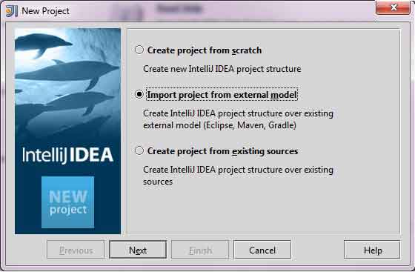

* Select Maven option

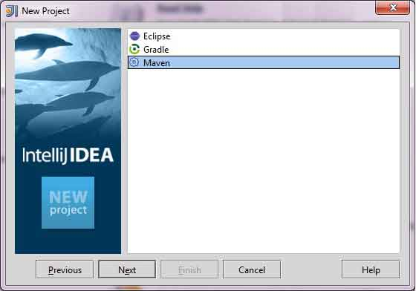

* Select Project location, where a project was created using Maven. We've create a Java Project consumerBanking.See [Maven Creating Project](https://www.tutorialspoint.com/maven/maven_creating_project.htm) to see how to create a project using Maven.

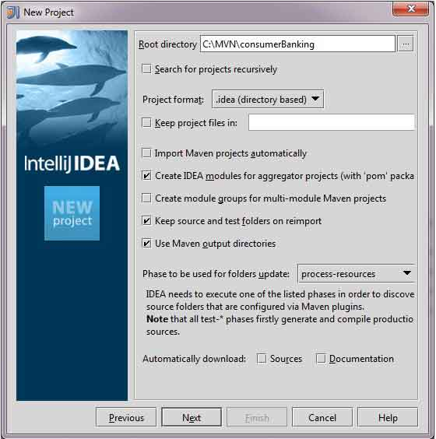

* Select Maven project to import.

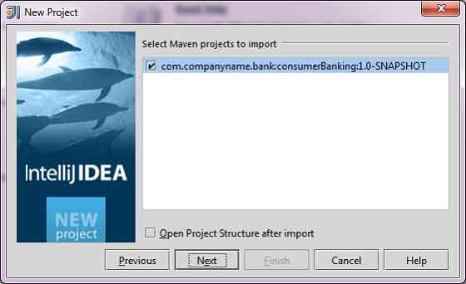

* Enter name of the project and click finish.

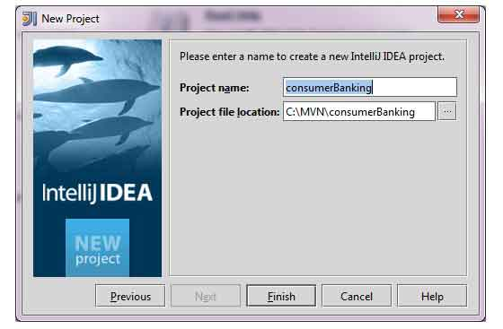

Now, you can see the maven project in IntelliJ IDEA.Have a look at consumerBanking project external libraries.You can see that IntelliJ IDEA has added Maven dependencies to its build path under Maven section.

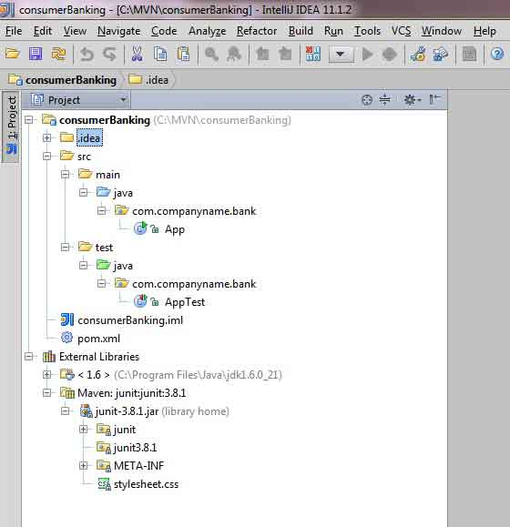

Build a maven project in IntelliJ IDEA

Now, Its time to build this project using capability of IntelliJ IDEA.

* Select consumerBanking project.
* Select **Buid menu > Rebuild Project** Option

You can see the output in IntelliJ IDEA Console

4:01:56 PM Compilation completed successfully

Run Application in IntelliJ IDEA

* Select consumerBanking project.
* Right click on App.java to open context menu.
* select **Run App.main()**

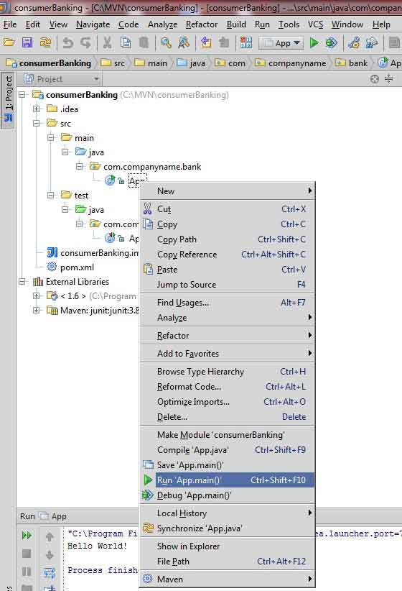

You will see the result in IntelliJ IDEA Console.

"C:\Program Files\Java\jdk1.6.0_21\bin\java"

-Didea.launcher.port=7533

"-Didea.launcher.bin.path=

C:\Program Files\JetBrains\IntelliJ IDEA Community Edition 11.1.2\bin"

-Dfile.encoding=UTF-8

-classpath "C:\Program Files\Java\jdk1.6.0_21\jre\lib\charsets.jar;

C:\Program Files\Java\jdk1.6.0_21\jre\lib\deploy.jar;

C:\Program Files\Java\jdk1.6.0_21\jre\lib\javaws.jar;

C:\Program Files\Java\jdk1.6.0_21\jre\lib\jce.jar;

C:\Program Files\Java\jdk1.6.0_21\jre\lib\jsse.jar;

C:\Program Files\Java\jdk1.6.0_21\jre\lib\management-agent.jar;

C:\Program Files\Java\jdk1.6.0_21\jre\lib\plugin.jar;

C:\Program Files\Java\jdk1.6.0_21\jre\lib\resources.jar;

C:\Program Files\Java\jdk1.6.0_21\jre\lib\rt.jar;

C:\Program Files\Java\jdk1.6.0_21\jre\lib\ext\dnsns.jar;

C:\Program Files\Java\jdk1.6.0_21\jre\lib\ext\localedata.jar;

C:\Program Files\Java\jdk1.6.0_21\jre\lib\ext\sunjce_provider.jar;

C:\Program Files\Java\jdk1.6.0_21\jre\lib\ext\sunmscapi.jar;

C:\Program Files\Java\jdk1.6.0_21\jre\lib\ext\sunpkcs11.jar

C:\MVN\consumerBanking\target\classes;

C:\Program Files\JetBrains\

IntelliJ IDEA Community Edition 11.1.2\lib\idea_rt.jar"

com.intellij.rt.execution.application.AppMain com.companyname.bank.App

**Hello World!**

Process finished with exit code 0